

**Packet Tracer - Configuring Named Standard ACLs** (Instructor Version)

**Instructor Note**: Red font color or Gray highlights indicate text that appears in the instructor copy only.

## Topology

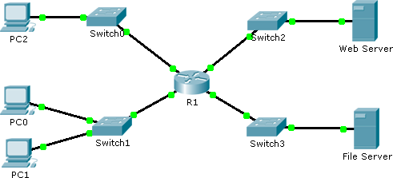

**Addressing Table**

|  |  |  |  |  |
| --- | --- | --- | --- | --- |
| **Device** | **Interface** | **IP Address** | **Subnet Mask** | **Default Gateway** |
| R1 | F0/0 | 192.168.10.1 | 255.255.255.0 | N/A |
| F0/1 | 192.168.20.1 | 255.255.255.0 | N/A |
| E0/0/0 | 192.168.100.1 | 255.255.255.0 | N/A |
| E0/1/0 | 192.168.200.1 | 255.255.255.0 | N/A |
| File Server | NIC | 192.168.200.100 | 255.255.255.0 | 192.168.200.1 |
| Web Server | NIC | 192.168.100.100 | 255.255.255.0 | 192.168.100.1 |
| PC0 | NIC | 192.168.20.3 | 255.255.255.0 | 192.168.20.1 |
| PC1 | NIC | 192.168.20.4 | 255.255.255.0 | 192.168.20.1 |
| PC2 | NIC | 192.168.10.3 | 255.255.255.0 | 192.168.10.1 |

**Objectives**

**Part 1: Configure and Apply a Named Standard ACL Part 2: Verify the ACL Implementation**

**Background / Scenario**

The senior network administrator has tasked you to create a standard named ACL to prevent access to a file server. All clients from one network and one specific workstation from a different network should be denied access.

**Packet Tracer - Configuring Named Standard ACLs**

**Part 1: Configure and Apply a Named Standard ACL**

**Step 1: Verify connectivity before the ACL is configured and applied.**

All three workstations should be able to ping both the **Web Server** and **File Server**.

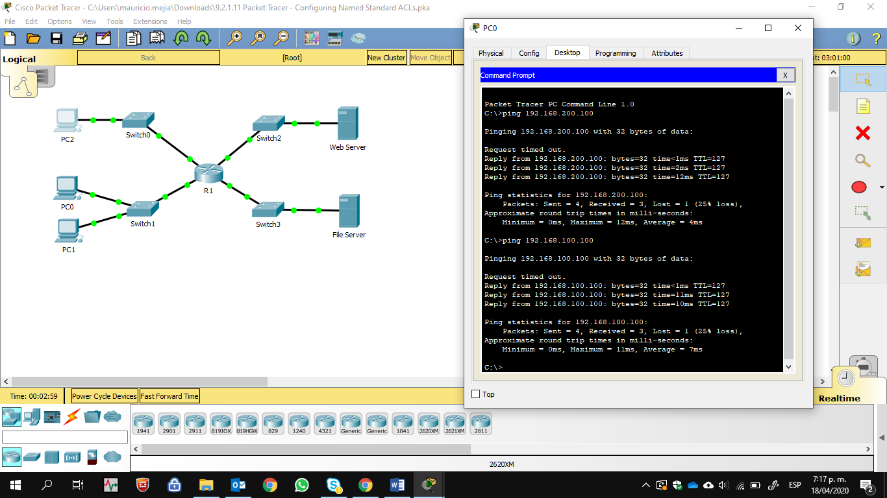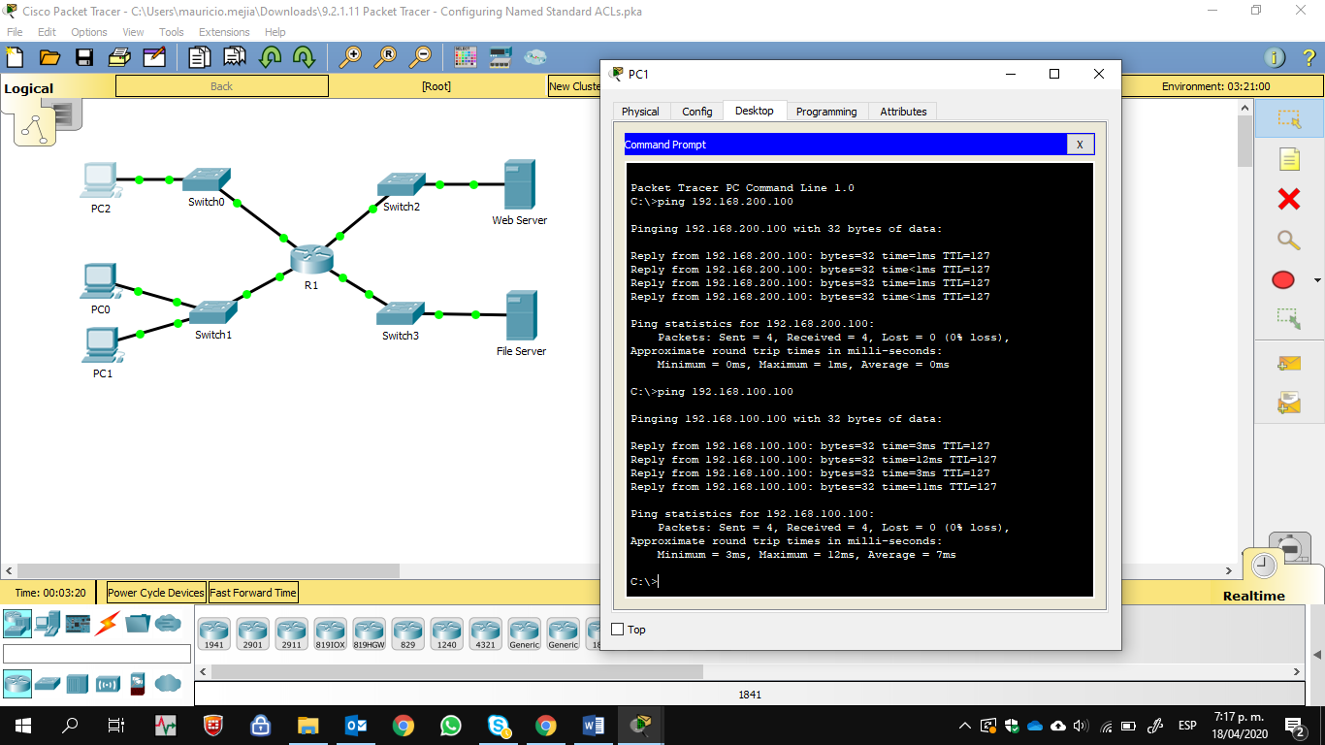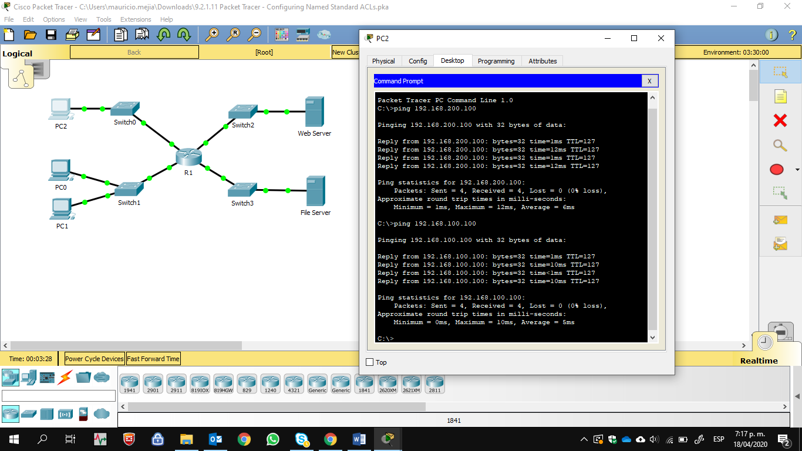

**Step 2: Configure a named standard ACL.**

Configure the following named ACL on **R1**.

R1(config)# **ip access-list standard File_Server_Restrictions**

R1(config-std-nacl)# **permit host 192.168.20.4**

R1(config-std-nacl)# **deny any**

**Note:** For scoring purposes, the ACL name is case-sensitive.

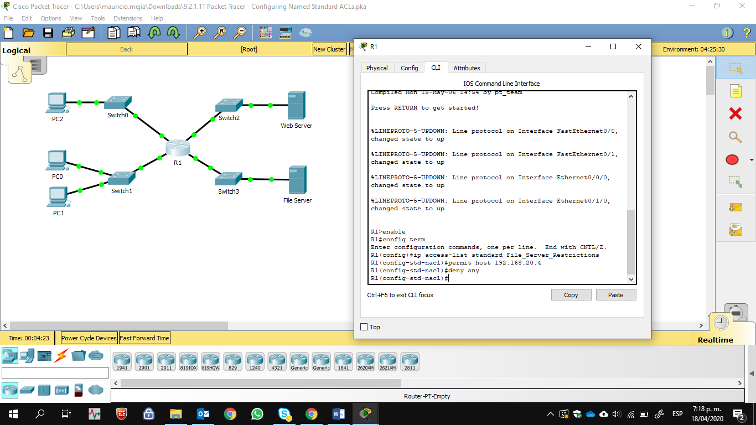

### Step 3: Apply the named ACL.

1. Apply the ACL outbound on the interface Fast Ethernet 0/1.

R1(config-if)# **ip access-group File_Server_Restrictions out**



1. Save the configuration.

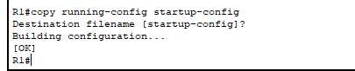

# Part 2: Verify the ACL Implementation

### Step 1: Verify the ACL configuration and application to the interface.

Use the **show access-lists** command to verify the ACL configuration. Use the **show run** or **show ip interface fastethernet 0/1** command to verify that the ACL is applied correctly to the interface.

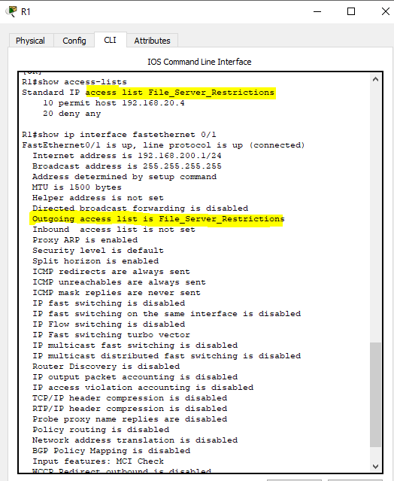

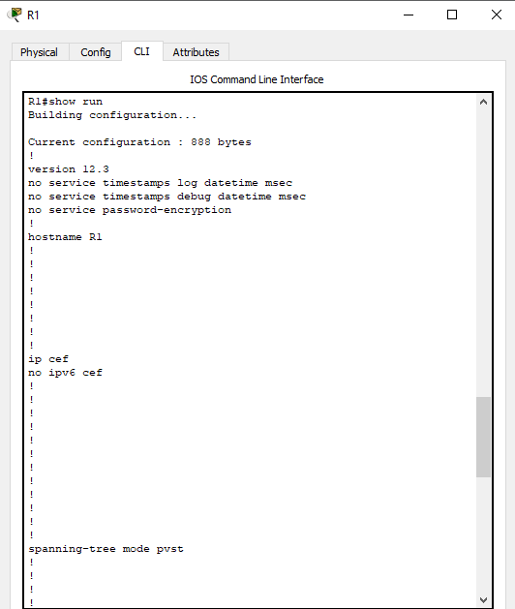 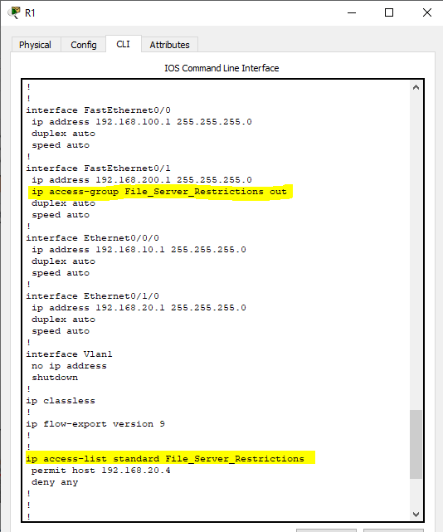 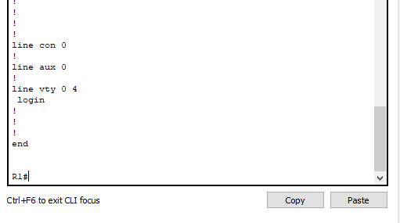

### Step 2: Verify that the ACL is working properly.

All three workstations should be able to ping the **Web Server**, but only **PC1** should be able to ping the **File Server**.

